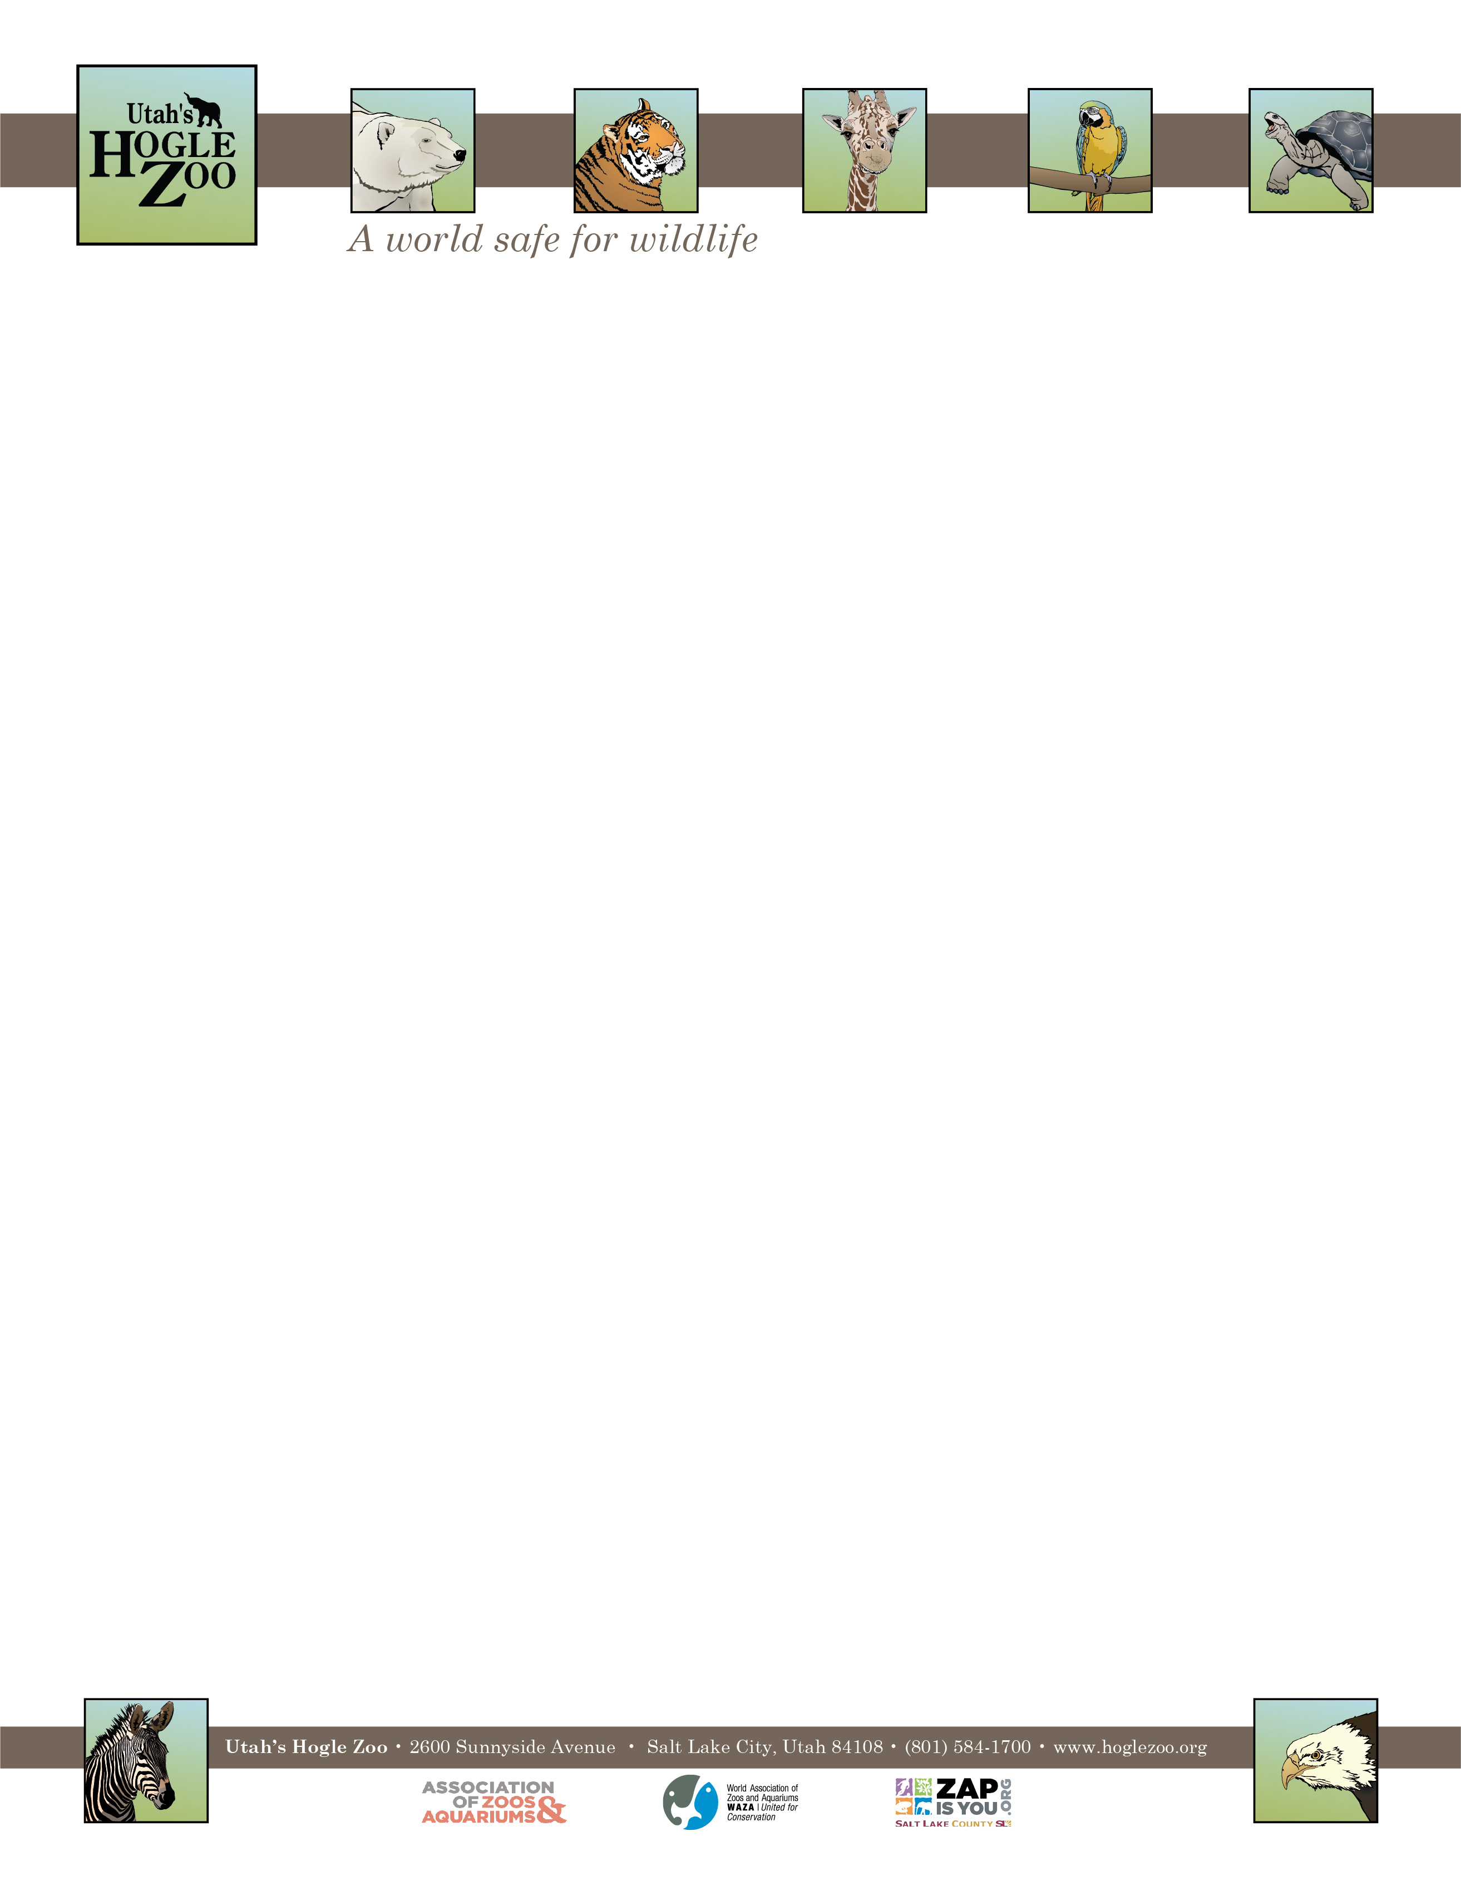

**Organization:** Utah’s Hogle Zoo (AZA Member) **Internship:** Graphics Internship

**Location:** Salt Lake City, Utah, United States

**POSITION SUMMARY:**

Do you dream of being a Graphics Intern at Utah’s Hogle Zoo?

Because you should, and here's why:

As our Graphics Intern you'll work closely with our Advancement Department whose skills range from Graphic Design, Print Production, Marketing, Special Events, Membership, and more. As part of Hogle Zoo’s creative team, you'll have the opportunity to work on a wide variety of projects including print, digital and other art based projects

**REPORTS TO:** Creative Works Coordinator

**DATES:** May 2nd – September 2nd, 2022 (start and end date may be flexible on a case by case basis)

**POSITION DESCRIPTION:**

Day to Day Responsibilities will be to work with the Creative Works Coordinator to develop and design graphics for multiple departments and perform various design tasks including image searching, social media ads, printing, sign maintenance and video editing to name a few.

* Design event signage and perform print production
* Learn about different marketing channels and how to design effectively across all of them
* Creatively solve problems from the concept to execution, including designs and layouts
* Manage multiple projects/tasks of varying complexities
* Brainstorm new ideas for future ad campaigns and video concepts

**QUALIFICATIONS:**

Be currently enrolled in/or have recently graduated from a college or university. Have a minimum of one year of course work in a major field of study to be applied during the internship (e.g. Graphic Design, Print Production, Commercial and Advertising Art, etc.).

* Must be detail-oriented and provide solutions on how to organize and handle design elements
* Must possess the ability to work independently and collaboratively in a fast-paced environment and meet deadlines

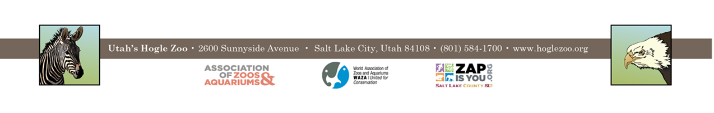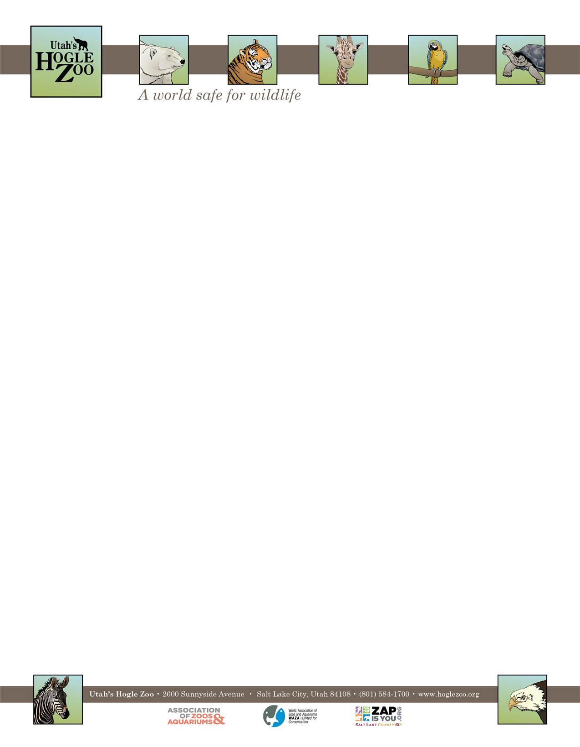

**QUALIFICATIONS CONTINUED:**

* Must have a keen eye for typography, color and layout; strong visual design skills, focused on details and quality
* Excellent communication, writing, documentation and presentation skills
* Ability to think strategically
* Proficient with Adobe Creative Suite, especially InDesign, Photoshop and Illustrator
* Currently pursuing or graduated with a Degree in Graphic Design, Fine Arts, UI/UX or related field
* Video and photo editing experience
* Only candidate submissions with portfolios will be considered

**WORK SCHEDULE:** 20-25 hours a week for a minimum of 12 weeks (with the possibility of an extension). Interns are expected to be available to work on occasional holidays and weekends.

**COMPENSATION:** The Graphics Intern position is unpaid. Professional development opportunities will be available. Possible college credit is available for those able to receive it through their college/university. No housing provided.

**TO APPLY:** Applications are due by **February 14, 2022**.

Please visit <https://www.hoglezoo.org/jobs_volunteers/internships/> to fill out an application. In addition to completing the application send a resume, cover letter, a link to a portfolio or PDF of portfolio, and informal transcript to [volunteeroffice@hoglezoo.org](mailto:volunteeroffice@hoglezoo.org)  .

Applicants will be contacted for interviews at the end of February, please do not expect to hear from us before then.

Please e-mail volunteeroffice@hoglezoo.org with any questions.

**Utah’s Hogle Zoo is committed to providing a diverse and inclusive internship program representative of a variety of backgrounds, age groups, perspectives, experiences, abilities, and strengths.**