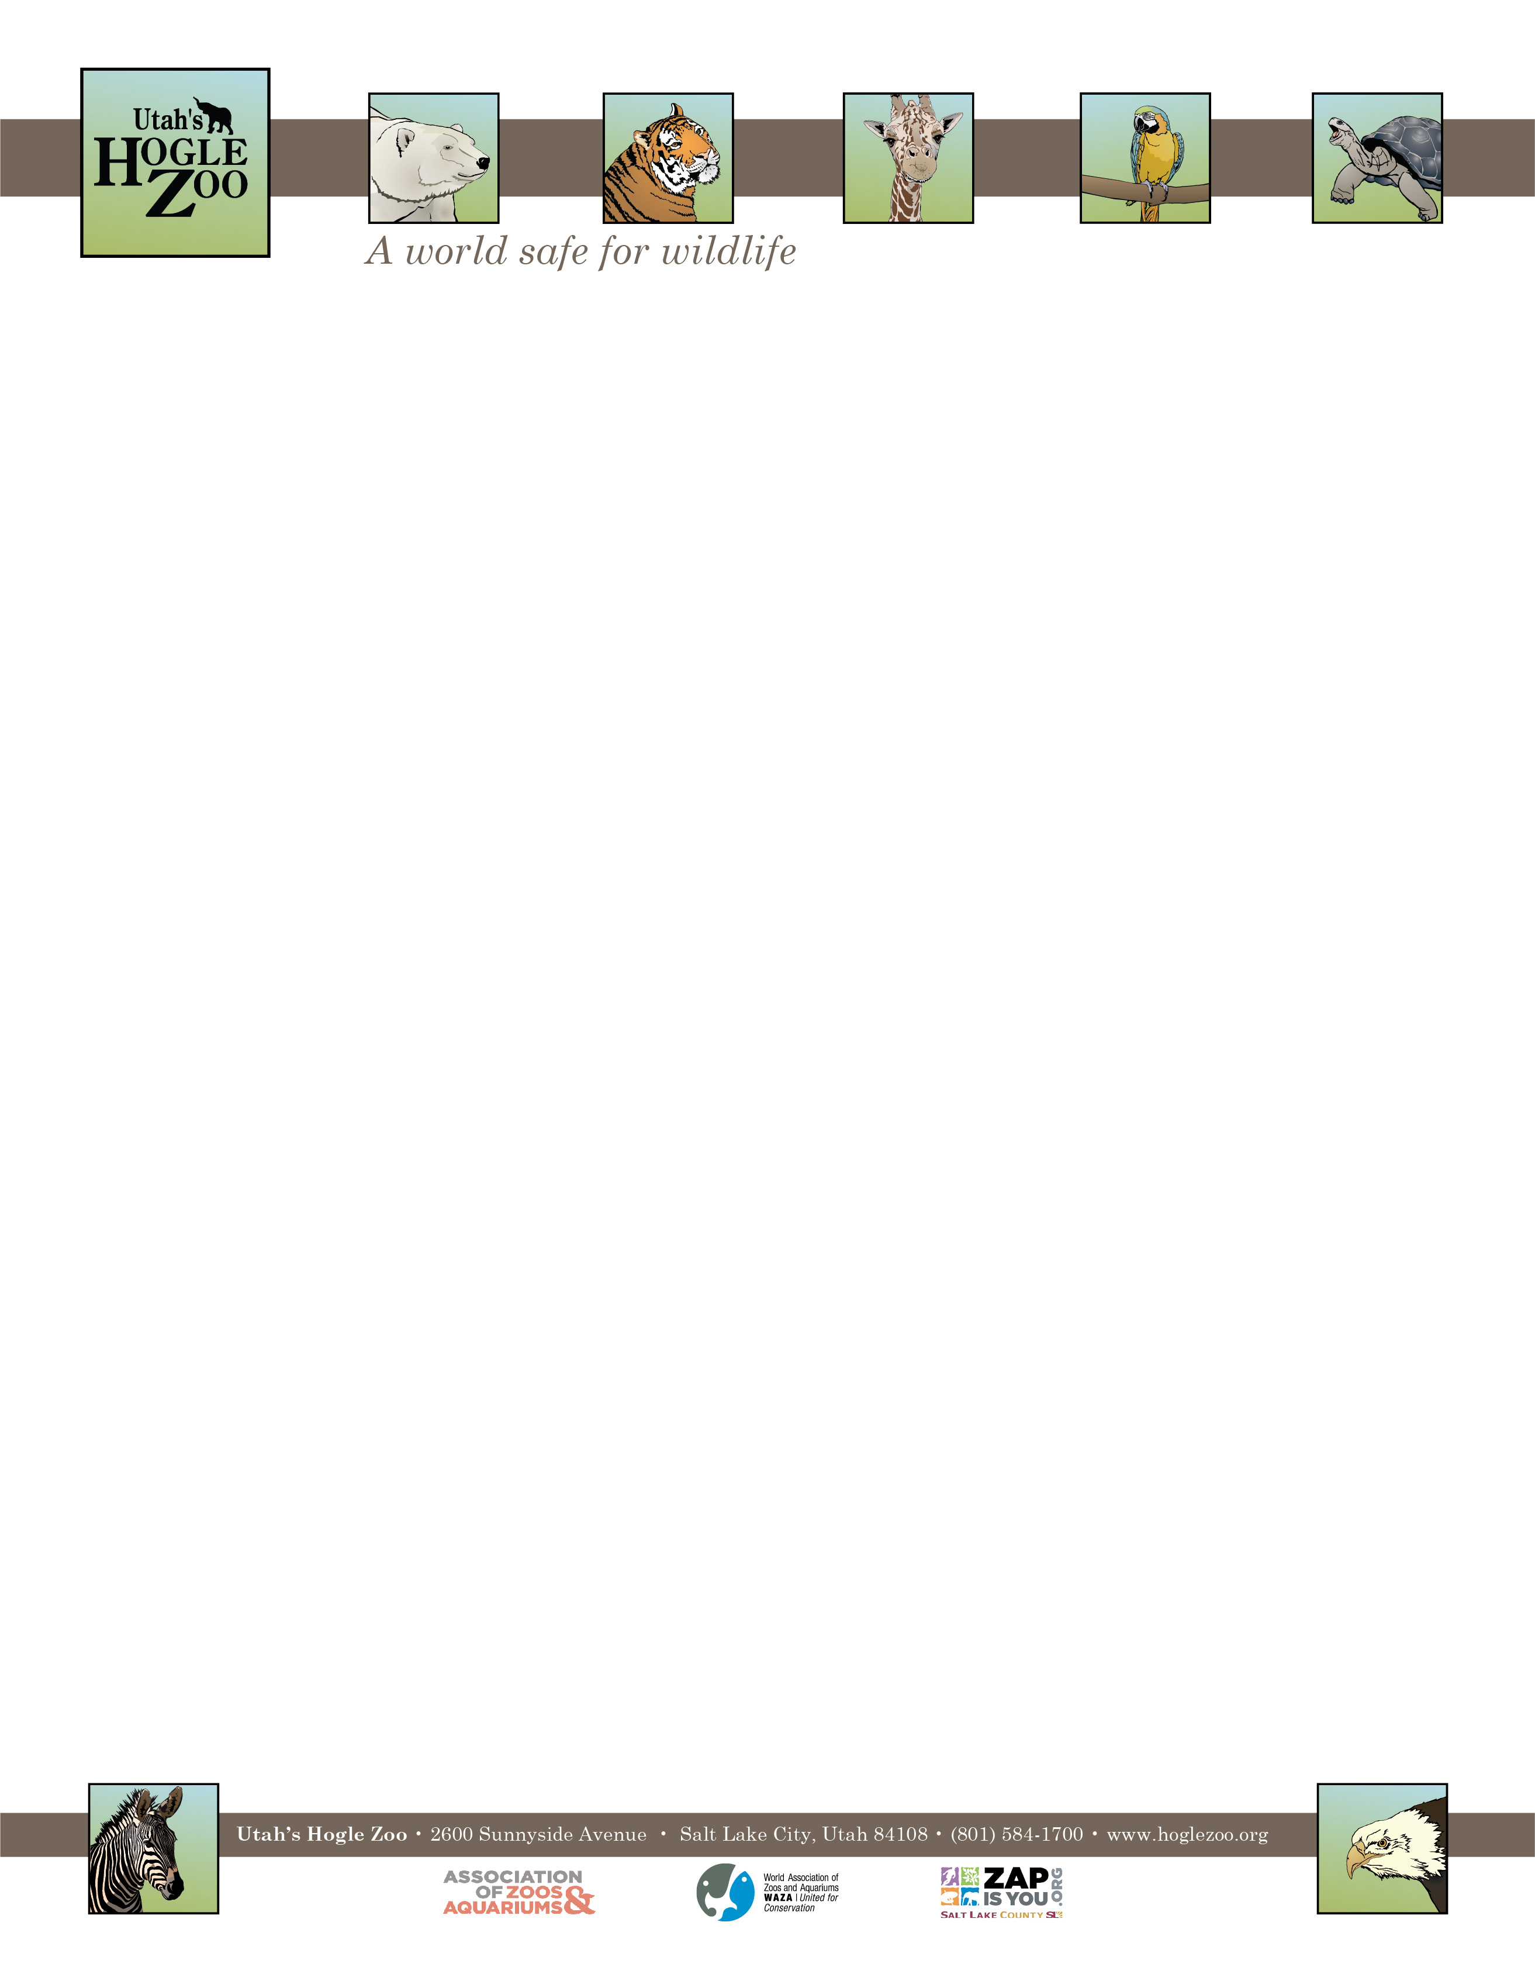

**Organization:** Utah’s Hogle Zoo (AZA Member) **Internship:** Animal Ambassadors Internship

**Location:** Salt Lake City, Utah, United States

**POSITION SUMMARY:**

This internship is geared towards college students and recent graduates who are interested in playing a direct role in caring for ambassador animals including small mammals, reptiles, invertebrates, amphibians, and birds. All applicants should be organized, self-motivated and have excellent people skills. This internship is an in-depth program requiring a 40-hour per week commitment for a total of 12 weeks. Interns must be flexible with their schedule, and have the ability to work weekdays, weekends and holidays. It is an unpaid position and there is no housing provided. Housing, travel expenses and transportation are the responsibilities of the candidate. Interns will be expected to complete a final project and keep a weekly journal as part of their internship.

**REPORTS TO:** Animal Care Supervisor of Ambassador Animals

**DATES:** Summer May 23- August 15, 2022 (start and end date may be flexible based on school schedule)

**POSITION DESCRIPTION:**

The selected candidate will assist the Animal Care staff in all aspects of caring for the Zoo’s Animal Ambassador Collection in both the Animal Resource Center and Creekside. This internship is designed to provide instruction in the following areas: animal husbandry, nutrition and diets, record keeping, public speaking, public education and knowledge of small mammals, reptiles, amphibians, invertebrates, and birds. Intern duties may include the following under keeper supervision (may vary based on skill level and departmental needs):

* Diet preparation and feeding
* Cleaning of animal exhibits and holding areas
* Exhibit maintenance
* Observing and recording animal condition, behaviors, and responses
* Positive educational interaction with Zoo guests, including scheduled public programs
* Animal enrichment
* Observation of animal training sessions
* Animal handling, as instructed in Animal Handling Policy and after proper orientation, training, and check off

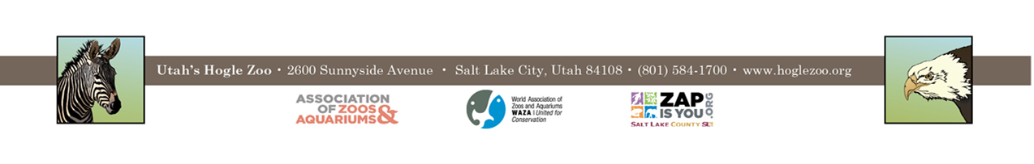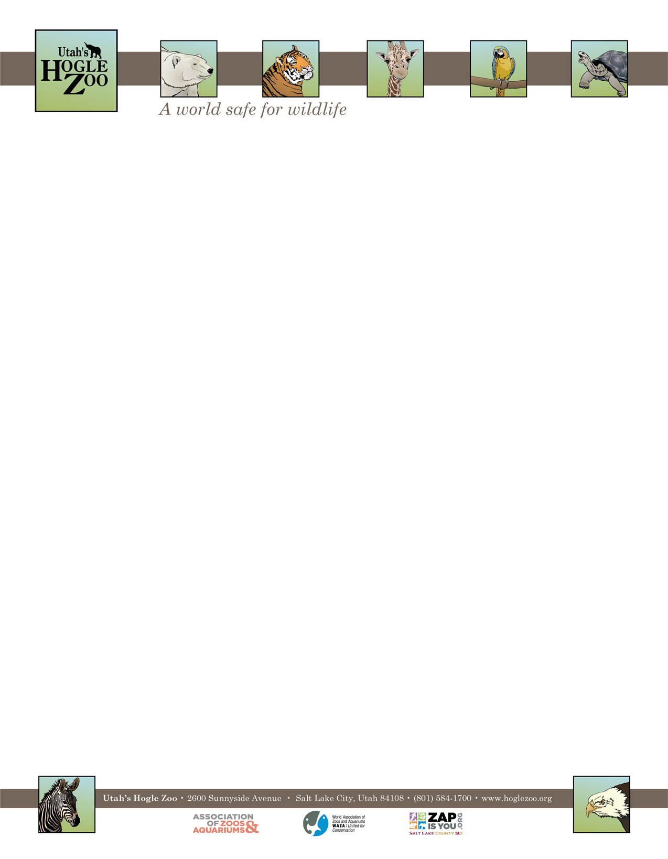

**QUALIFICATIONS:**

Be currently enrolled in a college or university, or have recently graduated. Have a minimum of one year of course work in a major field of study to be applied during the internship (e.g. Biology, Zoology, Environmental Science, etc.). Experience working with animals preferred. Applicant should have a strong career interest in animal husbandry and informal education in a zoological setting. Applicant should be comfortable speaking to large numbers of people at one time. Qualified applicants must be able to work in a team environment with people of all ages. They should be able to lift 50 pounds and work outdoors in the typical Utah climate. Interns need to have a recent TB test, and tetanus shot. The applicant needs to demonstrate maturity, self-motivation, and an ability to follow direction. A basic knowledge and understanding of computer word processing and PowerPoint is helpful. The ability to gain and hold a driver’s license is required. First Aid/CPR certified preferred.

**WORK SCHEDULE:** 40 hours a week for 12 weeks. Interns are expected to work on holidays and weekends.

**COMPENSATION:** The Animal Ambassadors internship is unpaid. Professional development opportunities will be available. Possible college credit is available for those able to receive it through their college/university. No housing provided.

**TO APPLY:** Applications are due by **February 14, 2022**.

Please visit <https://www.hoglezoo.org/jobs_volunteers/internships/> to fill out an application. In addition to completing the application send a resume, cover letter, and informal transcript to [volunteeroffice@hoglezoo.org](mailto:volunteeroffice@hoglezoo.org)  .

Applicants will be contacted for interviews at the end of February, please do not expect to hear from us before then.

Please e-mail volunteeroffice@hoglezoo.org with any questions.

**Utah’s Hogle Zoo is committed to providing a diverse and inclusive internship program representative of a variety of backgrounds, age groups, perspectives, experiences, abilities, and strengths.**