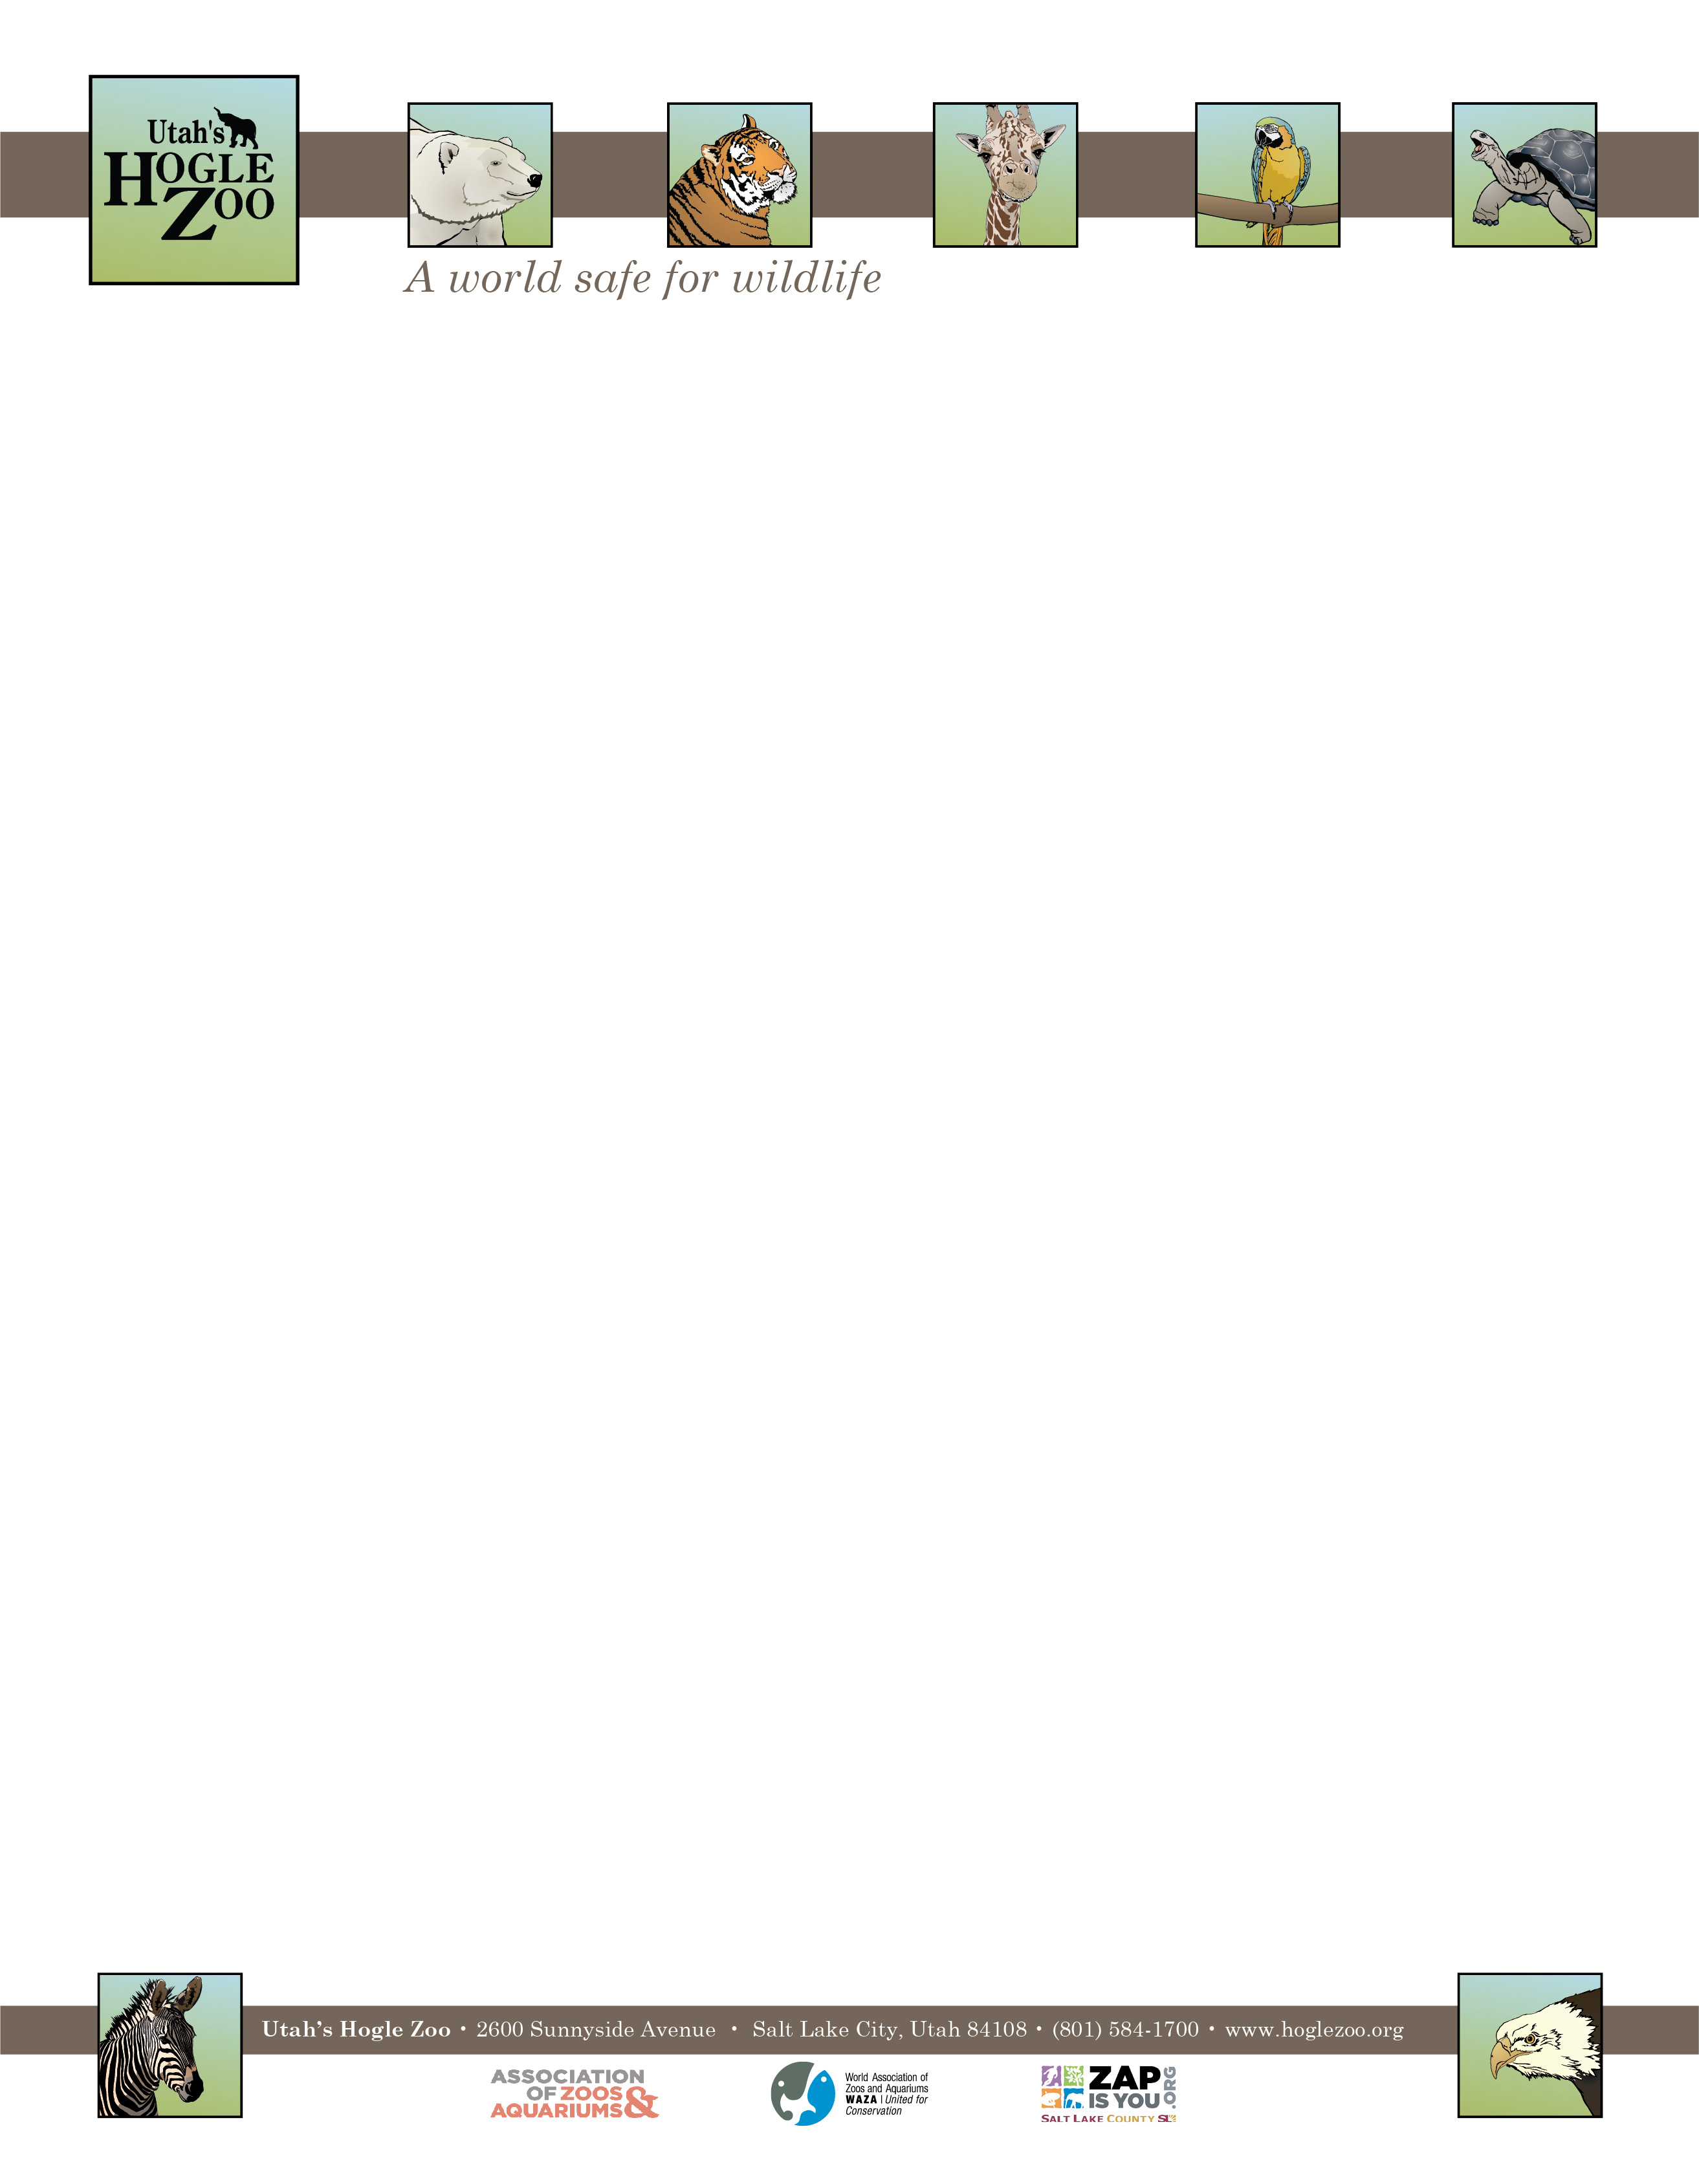

**Organization:** Utah’s Hogle Zoo (AZA Member) **Internship:** African Savanna Internship

**Location:** Salt Lake City, Utah, United States

**POSITION SUMMARY:**

This internship is geared towards college students and recent graduates who are interested in playing a direct role in caring for hoofstock and birds, including giraffe, Hartman’s mountain zebra, ostrich, warthog, guinea fowl, Turkmenian markhor, meerkats, African cape porcupines, and lions.**Interns may be restricted with their interactions with the lions**

All applicants should be organized, self-motivated and have excellent people skills. This internship is an

in-depth program requiring a 40 hour per week commitment for 12 weeks. Interns must be flexible with their schedule, and have the ability to work weekdays, weekends and holidays. It is an unpaid position and there is no housing provided. All internship positions are on a voluntary basis only. Housing, travel expenses and transportation are the responsibilities of the candidate.

**REPORTS TO:** Animal Care Supervisor of African Savanna

**DATES:** Summer May 23- August 15, 2022 (start and end date may be flexible based on school schedule)

**POSITION DESCRIPTION:**

The selected candidates will assist the Keeper staff in all aspects of caring for the Zoo’s animals in the African Savanna section. This internship is designed to provide instruction in the following areas: animal husbandry, nutrition and diet preparation, record keeping, public education and knowledge of species under your care. Intern duties may include the following under keeper supervision (may vary based on skill level and departmental needs):

1. Diet preparation and feeding
2. Cleaning of animal exhibits and holding areas
3. Exhibit maintenance
4. Observing and recording animal condition, behaviors, and responses
5. Positive and educational interaction with zoo guests
6. Animal enrichment
7. Training observation

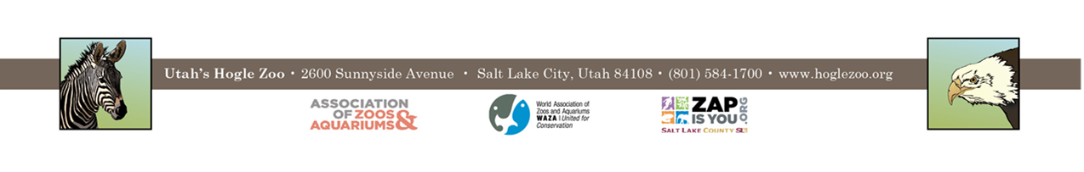

**QUALIFICATIONS:**

Be currently enrolled in a college or university, or have recently graduated. Have a minimum of one year of course work in a major field of study to be applied during the internship (e.g. Biology, Zoology, Environmental Science, etc.). Experience working with large animals preferred. Applicant should have a strong career interest in hoof stock and bird husbandry in a zoological setting. Qualified applicants must be able to work in a team environment, able to lift 50 lbs. and work outdoors in the typical Utah climate. Interns need to have a recent negative TB test and tetanus shot. They must also pass a background check and a drug test if selected. Because of the nature of working close to a variety of animals, both alongside the management and keeper staff, the applicant needs to demonstrate maturity, self-motivation, and an ability to follow direction. A basic knowledge and understanding of computer word processing and PowerPoint is helpful. The ability to gain and hold a driver’s license is required. First Aid/CPR certified preferred.

**WORK SCHEDULE:** 40 hours a week for a minimum of 12 weeks. Interns are expected to work on holidays and weekends.

**COMPENSATION:** The African Savanna Intern position is unpaid. Professional development opportunities will be available. Possible college credit is available for those able to receive it through their college/university. No housing provided.

**TO APPLY:** Applications are due by **February 14, 2022**.

Please visit <https://www.hoglezoo.org/jobs_volunteers/internships/> to fill out an application. In addition to completing the application send a resume, cover letter, and informal transcript to [volunteeroffice@hoglezoo.org](mailto:volunteeroffice@hoglezoo.org)  .

Applicants will be contacted for interviews at the end of February, please do not expect to hear from us before then.

Please e-mail volunteeroffice@hoglezoo.org with any questions.

**Utah’s Hogle Zoo is committed to providing a diverse and inclusive internship program representative of a variety of backgrounds, age groups, perspectives, experiences, abilities, and strengths.**