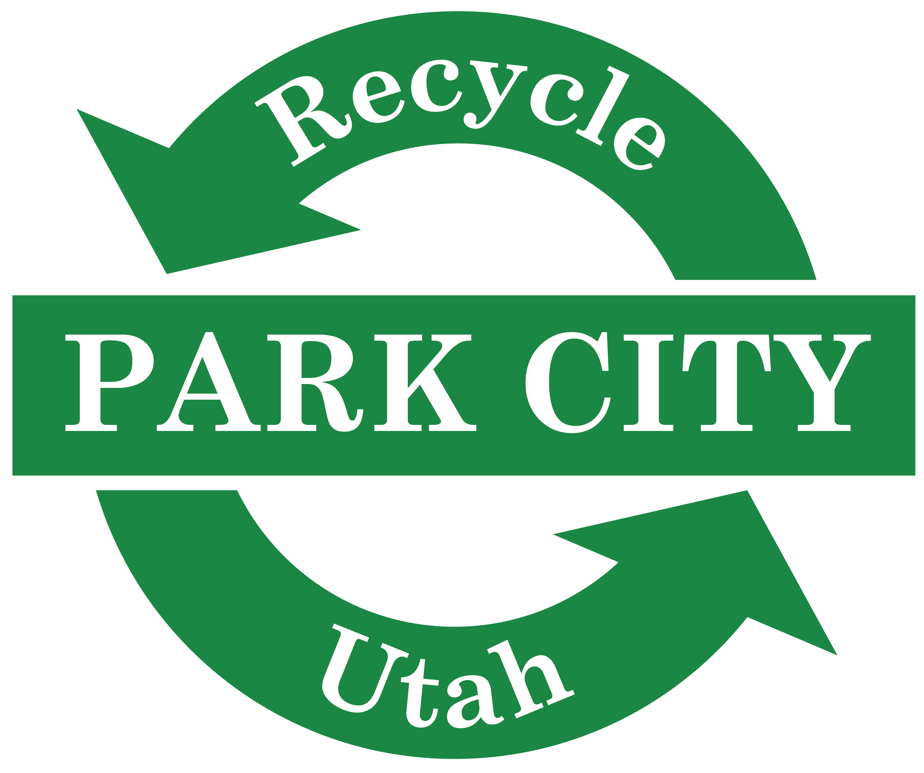

RECYCLE UTAH EDUCATION & OUTREACH INTERNSHIP

Recycle Utah, located in the heart of Park City, offers internships throughout the year in the spring (January – May), summer (June – August), and fall (September – December). If you are interested in gaining practical experience in environmental education K-8 and business outreach, this may be an ideal position for you. Additional responsibilities include outreach and marketing, environmental advocacy, and working with customers at our drop-off center. Opportunity exists to create your own project, the beauty of the non-profit industry.

Recycle Utah is seeking an intern to assist our staff with the following in 2019:
- Educate children on recycling, climate change, sustainable resource management, and water conservation.
- Assist with promotion and maintenance of our Green Business program.
- Represent Recycle Utah at outreach events across Summit County and all of Utah, while working to grow our support base.
- Research to support advocacy issues, including a plastic bag initiative, a statewide bottle bill, an EPS white packing foam ban, and an electronic-waste landfill ban.
- Help us operate Recycle Utah’s bustling 5,000 square-foot recycling center.

Requirements:
- Passion for, and knowledge of Recycle Utah’s work.
- Excellent written and verbal communication skills.
- Friendly and outgoing demeanor.
- Ability to commit 10 hours per week, with some evenings/weekends. Hours are flexible.

How to Apply:
- Submit a one-page cover letter, detailing your interest in the internship, and your relevant experience.
- Submit your resume, which should include relevant work and academic experience.
- Submit two professional, or academic references.

Please send application documents to Mary Closser at mary@recycleutah.org.

All interns are eligible for a final stipend after successful completion of the internship and items outlined and signed in Internship Agreement.

