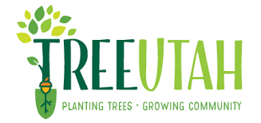

Internships available: Mapping, Social Media, and Community Engagement

Company/position description: TreeUtah works with students, municipalities, local businesses, community groups, and volunteers to plant trees in public spaces throughout the state. We plant trees of all types and sizes to make Utah a greener place to live, work, and play.

TreeUtah has identified three main areas of internship need: mapping, social media, and community engagement. Students are welcome to present their own ideas of how they would like to engage to TreeUtah as well.

Mapping would involve using GIS, Survey123 and other tools to map areas of interest to the organization and create working models. This would be a good opportunity to utilize these skills, but note that this cannot count as a for-credit GIS internship as the supervisor is not trained in GIS.

Social Media would utilize intern skills to create content for Facebook, Instagram, and YouTube to expand education and participation.

Likewise, Community Engagement would involve working with the community, finding ways to involve the existing community, and expand engagement with TreeUtah to new areas and demographics. This work would involve reaching out via email, phone, hanging posters and attending community meetings.

Address: 355 N 500 W, STE B, Salt Lake City, UT 84116. Hybrid work from home. All interns also attend TreeUtah events that are the heart of the work we do to plant trees with groups of volunteers in the communities most in need.
Contact: Contact Amy May at amy@treeutah.org with any questions.

To apply: email Amy May at amy@treeutah.org, including your resume and your area of internship interest.

